CORRELATIONS
/VARIABLES=homeeven pricheck Magmovies notbuypr homebody savecoup adwaste
/PRINT=TWOTAIL NOSIG
/MISSING=PAIRWISE.

Correlations

Notes
Output Created |  | 26-MAR-2017 15:29:36
Comments
Input | Data | C:\Home\Work\GreatLakes\Advanced Stats\practice data\household and shopping behaviour.sav
Input | Active Dataset | DataSet4
Input | Filter | <none>
Input | Weight | <none>
Input | Split File | <none>
Input | N of Rows in Working Data File | 25
Missing Value Handling | Definition of Missing | User-defined missing values are treated as missing.
Missing Value Handling | Cases Used | Statistics for each pair of variables are based on all the cases with valid data for that pair.
Syntax |  | CORRELATIONS  /VARIABLES=homeeven pricheck Magmovies notbuypr homebody savecoup adwaste  /PRINT=TWOTAIL NOSIG  /MISSING=PAIRWISE.
Resources | Processor Time | 00:00:00.03
Resources | Elapsed Time | 00:00:00.02

[DataSet4] C:\Home\Work\GreatLakes\Advanced Stats\practice data\household and shopping behaviour.sav

Correlations
 |  | Spent Evening at Home | Always Check Prices | Magazines Better Than Movies
Spent Evening at Home | Pearson Correlation | 1 | -.004 | .628**
Spent Evening at Home | Sig. (2-tailed) |  | .985 | .001
Spent Evening at Home | N | 25 | 25 | 25
Always Check Prices | Pearson Correlation | -.004 | 1 | .151
Always Check Prices | Sig. (2-tailed) | .985 |  | .472
Always Check Prices | N | 25 | 25 | 25
Magazines Better Than Movies | Pearson Correlation | .628** | .151 | 1
Magazines Better Than Movies | Sig. (2-tailed) | .001 | .472
Magazines Better Than Movies | N | 25 | 25 | 25
Would Not Buy Products on Billboards | Pearson Correlation | .082 | -.248 | -.182
Would Not Buy Products on Billboards | Sig. (2-tailed) | .695 | .232 | .384
Would Not Buy Products on Billboards | N | 25 | 25 | 25
Am a Homebody | Pearson Correlation | .675** | .048 | .480*
Am a Homebody | Sig. (2-tailed) | .000 | .819 | .015
Am a Homebody | N | 25 | 25 | 25
Save and Cash Coupons | Pearson Correlation | -.100 | .582** | .090
Save and Cash Coupons | Sig. (2-tailed) | .633 | .002 | .667
Save and Cash Coupons | N | 25 | 25 | 25
Ads are Waste | Pearson Correlation | -.338 | -.251 | -.588**
Ads are Waste | Sig. (2-tailed) | .099 | .226 | .002
Ads are Waste | N | 25 | 25 | 25

Correlations
 |  | Would Not Buy Products on Billboards | Am a Homebody | Save and Cash Coupons
Spent Evening at Home | Pearson Correlation | .082 | .675 | -.100**
Spent Evening at Home | Sig. (2-tailed) | .695 | .000 | .633
Spent Evening at Home | N | 25 | 25 | 25
Always Check Prices | Pearson Correlation | -.248 | .048 | .582
Always Check Prices | Sig. (2-tailed) | .232 | .819 | .002
Always Check Prices | N | 25 | 25 | 25
Magazines Better Than Movies | Pearson Correlation | -.182** | .480 | .090
Magazines Better Than Movies | Sig. (2-tailed) | .384 | .015 | .667
Magazines Better Than Movies | N | 25 | 25 | 25
Would Not Buy Products on Billboards | Pearson Correlation | 1 | .272 | .017
Would Not Buy Products on Billboards | Sig. (2-tailed) |  | .189 | .937
Would Not Buy Products on Billboards | N | 25 | 25 | 25
Am a Homebody | Pearson Correlation | .272** | 1 | -.110*
Am a Homebody | Sig. (2-tailed) | .189 |  | .601
Am a Homebody | N | 25 | 25 | 25
Save and Cash Coupons | Pearson Correlation | .017 | -.110** | 1
Save and Cash Coupons | Sig. (2-tailed) | .937 | .601
Save and Cash Coupons | N | 25 | 25 | 25
Ads are Waste | Pearson Correlation | .469 | -.082 | .014**
Ads are Waste | Sig. (2-tailed) | .018 | .696 | .946
Ads are Waste | N | 25 | 25 | 25

Correlations
 |  | Ads are Waste
Spent Evening at Home | Pearson Correlation | -.338
Spent Evening at Home | Sig. (2-tailed) | .099
Spent Evening at Home | N | 25
Always Check Prices | Pearson Correlation | -.251
Always Check Prices | Sig. (2-tailed) | .226
Always Check Prices | N | 25
Magazines Better Than Movies | Pearson Correlation | -.588**
Magazines Better Than Movies | Sig. (2-tailed) | .002
Magazines Better Than Movies | N | 25
Would Not Buy Products on Billboards | Pearson Correlation | .469
Would Not Buy Products on Billboards | Sig. (2-tailed) | .018
Would Not Buy Products on Billboards | N | 25
Am a Homebody | Pearson Correlation | -.082**
Am a Homebody | Sig. (2-tailed) | .696
Am a Homebody | N | 25
Save and Cash Coupons | Pearson Correlation | .014
Save and Cash Coupons | Sig. (2-tailed) | .946
Save and Cash Coupons | N | 25
Ads are Waste | Pearson Correlation | 1
Ads are Waste | Sig. (2-tailed)
Ads are Waste | N | 25

**. Correlation is significant at the 0.01 level (2-tailed).
*. Correlation is significant at the 0.05 level (2-tailed).

REGRESSION
/MISSING LISTWISE
/STATISTICS COEFF OUTS R ANOVA
/CRITERIA=PIN(.05) POUT(.10)
/NOORIGIN
/DEPENDENT tentruor
/METHOD=ENTER homeeven pricheck Magmovies notbuypr homebody savecoup adwaste
/RESIDUALS HISTOGRAM(ZRESID).

Regression

Notes
Output Created |  | 26-MAR-2017 15:32:04
Comments
Input | Data | C:\Home\Work\GreatLakes\Advanced Stats\practice data\household and shopping behaviour.sav
Input | Active Dataset | DataSet4
Input | Filter | <none>
Input | Weight | <none>
Input | Split File | <none>
Input | N of Rows in Working Data File | 25
Missing Value Handling | Definition of Missing | User-defined missing values are treated as missing.
Missing Value Handling | Cases Used | Statistics are based on cases with no missing values for any variable used.
Syntax |  | REGRESSION  /MISSING LISTWISE  /STATISTICS COEFF OUTS R ANOVA  /CRITERIA=PIN(.05) POUT(.10)  /NOORIGIN  /DEPENDENT tentruor  /METHOD=ENTER homeeven pricheck Magmovies notbuypr homebody savecoup adwaste  /RESIDUALS HISTOGRAM(ZRESID).
Resources | Processor Time | 00:00:00.39
Resources | Elapsed Time | 00:00:00.42
Resources | Memory Required | 6432 bytes
Resources | Additional Memory Required for Residual Plots | 216 bytes

[DataSet4] C:\Home\Work\GreatLakes\Advanced Stats\practice data\household and shopping behaviour.sav

Variables Entered/Removedª
Model | Variables Entered | Variables Removed | Method
1 | Ads are Waste, Save and Cash Coupons, Am a Homebody, Would Not Buy Products on Billboards, Always Check Prices, Spent Evening at Home, Magazines Better Than Movies^{b} | . | Enter

a. Dependent Variable: Tendency to trust online reviews
b. All requested variables entered.

Model Summary^{b}
Model | R | R Square | Adjusted R Square | Std. Error of the Estimate
1 | .864ª | .746 | .641 | .93478

a. Predictors: (Constant), Ads are Waste, Save and Cash Coupons, Am a Homebody, Would Not Buy Products on Billboards, Always Check Prices, Spent Evening at Home, Magazines Better Than Movies
b. Dependent Variable: Tendency to trust online reviews

ANOVAª
Model |  | Sum of Squares | df | Mean Square | F | Sig.
1 | Regression | 43.580 | 7 | 6.226 | 7.125 | .000^{b}
1 | Residual | 14.855 | 17 | .874
1 | Total | 58.435 | 24

a. Dependent Variable: Tendency to trust online reviews
b. Predictors: (Constant), Ads are Waste, Save and Cash Coupons, Am a Homebody, Would Not Buy Products on Billboards, Always Check Prices, Spent Evening at Home, Magazines Better Than Movies

Coefficientsª
Model |  | Unstandardized Coefficients |  | Standardized Coefficients | t | Sig.
 |  | B | Std. Error | Beta | t | Sig.
1 | (Constant) | -4.693 | 1.168 |  | -4.017 | .001
1 | Spent Evening at Home | .534 | .161 | .638 | 3.317 | .004
1 | Always Check Prices | .429 | .143 | .511 | 2.996 | .008
1 | Magazines Better Than Movies | .301 | .173 | .346 | 1.739 | .100
1 | Would Not Buy Products on Billboards | .310 | .135 | .357 | 2.296 | .035
1 | Am a Homebody | -.128 | .154 | -.158 | -.832 | .417
1 | Save and Cash Coupons | -.173 | .142 | -.204 | -1.220 | .239
1 | Ads are Waste | .404 | .148 | .490 | 2.725 | .014

a. Dependent Variable: Tendency to trust online reviews

Spent Evening at Home, Always Check Prices, Would not boy Products on Billboards, Ads are waste is Significant and +vely impacts

Residuals Statisticsª
 | Minimum | Maximum | Mean | Std. Deviation | N
Predicted Value | .0796 | 5.1690 | 2.2400 | 1.34753 | 25
Residual | -1.57304 | 1.03723 | .00000 | .78673 | 25
Std. Predicted Value | -1.603 | 2.174 | .000 | 1.000 | 25
Std. Residual | -1.683 | 1.110 | .000 | .842 | 25

a. Dependent Variable: Tendency to trust online reviews

Charts

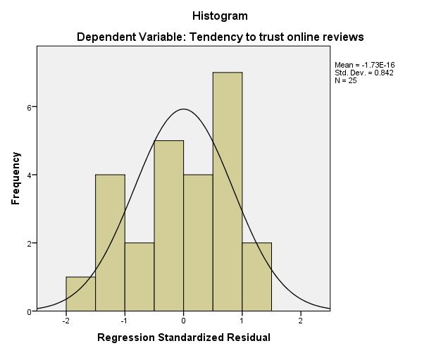

FACTOR
/VARIABLES homeeven pricheck Magmovies notbuypr homebody savecoup adwaste
/MISSING LISTWISE
/ANALYSIS homeeven pricheck Magmovies notbuypr homebody savecoup adwaste
/PRINT INITIAL EXTRACTION FSCORE
/PLOT EIGEN
/CRITERIA MINEIGEN(1) ITERATE(25)
/EXTRACTION PC
/ROTATION NOROTATE
/SAVE REG(ALL)
/METHOD=CORRELATION.

Factor Analysis

Notes
Output Created |  | 26-MAR-2017 15:37:07
Comments
Input | Data | C:\Home\Work\GreatLakes\Advanced Stats\practice data\household and shopping behaviour.sav
Input | Active Dataset | DataSet4
Input | Filter | <none>
Input | Weight | <none>
Input | Split File | <none>
Input | N of Rows in Working Data File | 25
Missing Value Handling | Definition of Missing | MISSING=EXCLUDE: User-defined missing values are treated as missing.
Missing Value Handling | Cases Used | LISTWISE: Statistics are based on cases with no missing values for any variable used.
Syntax |  | FACTOR  /VARIABLES homeeven pricheck Magmovies notbuypr homebody savecoup adwaste  /MISSING LISTWISE  /ANALYSIS homeeven pricheck Magmovies notbuypr homebody savecoup adwaste  /PRINT INITIAL EXTRACTION FSCORE  /PLOT EIGEN  /CRITERIA MINEIGEN(1) ITERATE(25)  /EXTRACTION PC  /ROTATION NOROTATE  /SAVE REG(ALL)  /METHOD=CORRELATION.

Notes
Resources | Processor Time | 00:00:00.28
Resources | Elapsed Time | 00:00:00.27
Resources | Maximum Memory Required | 7896 (7.711K) bytes
Variables Created | FAC1_1 | Component score 1
Variables Created | FAC2_1 | Component score 2
Variables Created | FAC3_1 | Component score 3

[DataSet4] C:\Home\Work\GreatLakes\Advanced Stats\practice data\household and shopping behaviour.sav

Communalities
 | Initial | Extraction
Spent Evening at Home | 1.000 | .818
Always Check Prices | 1.000 | .796
Magazines Better Than Movies | 1.000 | .790
Would Not Buy Products on Billboards | 1.000 | .800
Am a Homebody | 1.000 | .805
Save and Cash Coupons | 1.000 | .841
Ads are Waste | 1.000 | .796

Extraction Method: Principal Component Analysis.

Total Variance Explained
Component | Initial Eigenvalues |  |  | Extraction Sums of Squared Loadings
Component | Total | % of Variance | Cumulative % | Total | % of Variance | Cumulative %
1 | 2.485 | 35.505 | 35.505 | 2.485 | 35.505 | 35.505
2 | 1.821 | 26.013 | 61.518 | 1.821 | 26.013 | 61.518
3 | 1.339 | 19.131 | 80.649 | 1.339 | 19.131 | 80.649
4 | .508 | 7.258 | 87.907
5 | .376 | 5.373 | 93.280
6 | .279 | 3.990 | 97.270
7 | .191 | 2.730 | 100.000

Extraction Method: Principal Component Analysis.

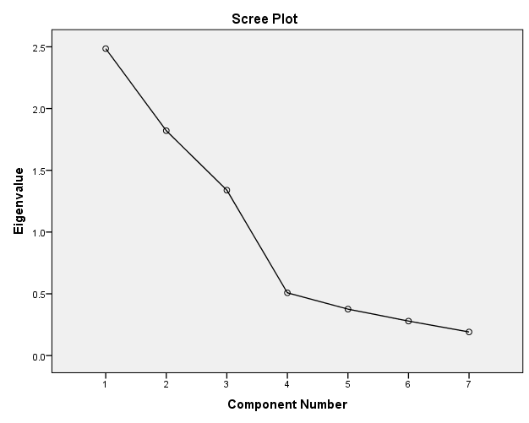

Component Matrixª
 | Component
 | 1 | 2 | 3
Spent Evening at Home | .817 | .378 | .087
Always Check Prices | .279 | -.714 | .457
Magazines Better Than Movies | .887 | -.027 | -.043
Would Not Buy Products on Billboards | -.204 | .634 | .597
Am a Homebody | .664 | .505 | .329
Save and Cash Coupons | .050 | -.604 | .689
Ads are Waste | -.684 | .383 | .426

Extraction Method: Principal Component Analysis.ª
a. 3 components extracted.

Factor 1
Spent Evening at home
Magazines Better Than Movies
Am a Homebody
Ads are waste

Factor 2
Always Check Prices
Would not Buy Products on Billbords
Am a Homebody
Save and Cash Coupons

Factor 3
Spent Evening at Home
Always Check Prices
Would not Buy Products on Billbords
Save and Cash Coupons

There are lots of Variables loadin in multiple Factors

Component Score Coefficient Matrix
 | Component
 | 1 | 2 | 3
Spent Evening at Home | .329 | .208 | .065
Always Check Prices | .112 | -.392 | .342
Magazines Better Than Movies | .357 | -.015 | -.032
Would Not Buy Products on Billboards | -.082 | .348 | .446
Am a Homebody | .267 | .278 | .246
Save and Cash Coupons | .020 | -.331 | .514
Ads are Waste | -.275 | .210 | .318

Extraction Method: Principal Component Analysis.
Component Scores.

Component Score Covariance Matrix
Component | 1 | 2 | 3
1 | 1.000 | .000 | .000
2 | .000 | 1.000 | .000
3 | .000 | .000 | 1.000

Extraction Method: Principal Component Analysis.
Component Scores.

CORRELATIONS
/VARIABLES=FAC1_1 FAC2_1 FAC3_1
/PRINT=TWOTAIL NOSIG
/MISSING=PAIRWISE.

Correlations

Notes
Output Created |  | 26-MAR-2017 15:42:52
Comments
Input | Data | C:\Home\Work\GreatLakes\Advanced Stats\practice data\household and shopping behaviour.sav
Input | Active Dataset | DataSet4
Input | Filter | <none>
Input | Weight | <none>
Input | Split File | <none>
Input | N of Rows in Working Data File | 25
Missing Value Handling | Definition of Missing | User-defined missing values are treated as missing.
Missing Value Handling | Cases Used | Statistics for each pair of variables are based on all the cases with valid data for that pair.
Syntax |  | CORRELATIONS  /VARIABLES=FAC1_1 FAC2_1 FAC3_1  /PRINT=TWOTAIL NOSIG  /MISSING=PAIRWISE.
Resources | Processor Time | 00:00:00.00
Resources | Elapsed Time | 00:00:00.01

[DataSet4] C:\Home\Work\GreatLakes\Advanced Stats\practice data\household and shopping behaviour.sav

Correlations
 |  | REGR factor score 1 for analysis 1 | REGR factor score 2 for analysis 1 | REGR factor score 3 for analysis 1
REGR factor score 1 for analysis 1 | Pearson Correlation | 1 | .000 | .000
REGR factor score 1 for analysis 1 | Sig. (2-tailed) |  | 1.000 | 1.000
REGR factor score 1 for analysis 1 | N | 25 | 25 | 25
REGR factor score 2 for analysis 1 | Pearson Correlation | .000 | 1 | .000
REGR factor score 2 for analysis 1 | Sig. (2-tailed) | 1.000 |  | 1.000
REGR factor score 2 for analysis 1 | N | 25 | 25 | 25
REGR factor score 3 for analysis 1 | Pearson Correlation | .000 | .000 | 1
REGR factor score 3 for analysis 1 | Sig. (2-tailed) | 1.000 | 1.000
REGR factor score 3 for analysis 1 | N | 25 | 25 | 25

It is very Orthogonal but I could not answe as I don't know the factors.

REGRESSION
/MISSING LISTWISE
/STATISTICS COEFF OUTS R ANOVA
/CRITERIA=PIN(.05) POUT(.10)
/NOORIGIN
/DEPENDENT tentruor
/METHOD=ENTER FAC1_1 FAC2_1 FAC3_1
/RESIDUALS HISTOGRAM(ZRESID).

Regression

Notes
Output Created |  | 26-MAR-2017 15:43:50
Comments
Input | Data | C:\Home\Work\GreatLakes\Advanced Stats\practice data\household and shopping behaviour.sav
Input | Active Dataset | DataSet4
Input | Filter | <none>
Input | Weight | <none>
Input | Split File | <none>
Input | N of Rows in Working Data File | 25
Missing Value Handling | Definition of Missing | User-defined missing values are treated as missing.
Missing Value Handling | Cases Used | Statistics are based on cases with no missing values for any variable used.
Syntax |  | REGRESSION  /MISSING LISTWISE  /STATISTICS COEFF OUTS R ANOVA  /CRITERIA=PIN(.05) POUT(.10)  /NOORIGIN  /DEPENDENT tentruor  /METHOD=ENTER FAC1_1 FAC2_1 FAC3_1  /RESIDUALS HISTOGRAM(ZRESID).
Resources | Processor Time | 00:00:00.28
Resources | Elapsed Time | 00:00:00.30
Resources | Memory Required | 3792 bytes
Resources | Additional Memory Required for Residual Plots | 280 bytes

[DataSet4] C:\Home\Work\GreatLakes\Advanced Stats\practice data\household and shopping behaviour.sav

Variables Entered/Removedª
Model | Variables Entered | Variables Removed | Method
1 | REGR factor score 3 for analysis 1, REGR factor score 2 for analysis 1, REGR factor score 1 for analysis 1^{b} | . | Enter

a. Dependent Variable: Tendency to trust online reviews
b. All requested variables entered.

Model Summary^{b}
Model | R | R Square | Adjusted R Square | Std. Error of the Estimate
1 | .748ª | .559 | .496 | 1.10782

a. Predictors: (Constant), REGR factor score 3 for analysis 1, REGR factor score 2 for analysis 1, REGR factor score 1 for analysis 1
b. Dependent Variable: Tendency to trust online reviews

ANOVAª
Model |  | Sum of Squares | df | Mean Square | F | Sig.
1 | Regression | 32.662 | 3 | 10.887 | 8.871 | .001^{b}
1 | Residual | 25.773 | 21 | 1.227
1 | Total | 58.435 | 24

a. Dependent Variable: Tendency to trust online reviews
b. Predictors: (Constant), REGR factor score 3 for analysis 1, REGR factor score 2 for analysis 1, REGR factor score 1 for analysis 1

Coefficientsª
Model |  | Unstandardized Coefficients |  | Standardized Coefficients | t | Sig.
 |  | B | Std. Error | Beta | t | Sig.
1 | (Constant) | 2.240 | .222 |  | 10.110 | .000
1 | REGR factor score 1 for analysis 1 | .698 | .226 | .447 | 3.086 | .006
1 | REGR factor score 2 for analysis 1 | .506 | .226 | .325 | 2.239 | .036
1 | REGR factor score 3 for analysis 1 | .786 | .226 | .504 | 3.475 | .002

a. Dependent Variable: Tendency to trust online reviews

All the factors are Sinificant and Not sure what to Advice

Residuals Statisticsª
 | Minimum | Maximum | Mean | Std. Deviation | N
Predicted Value | .1579 | 4.0994 | 2.2400 | 1.16659 | 25
Residual | -2.11566 | 1.78052 | .00000 | 1.03627 | 25
Std. Predicted Value | -1.785 | 1.594 | .000 | 1.000 | 25
Std. Residual | -1.910 | 1.607 | .000 | .935 | 25

a. Dependent Variable: Tendency to trust online reviews

Charts

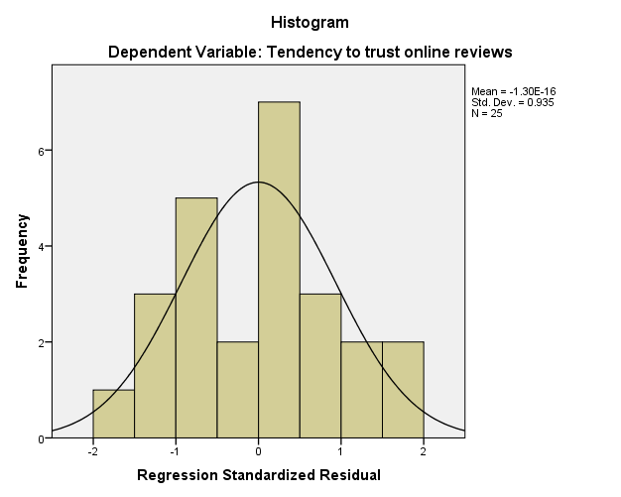

FACTOR
/VARIABLES homeeven pricheck Magmovies notbuypr homebody savecoup adwaste
/MISSING LISTWISE
/ANALYSIS homeeven pricheck Magmovies notbuypr homebody savecoup adwaste
/PRINT INITIAL EXTRACTION ROTATION FSCORE
/PLOT EIGEN ROTATION
/CRITERIA MINEIGEN(1) ITERATE(25)
/EXTRACTION PC
/CRITERIA ITERATE(25)
/ROTATION VARIMAX
/SAVE REG(ALL)
/METHOD=CORRELATION.

Factor Analysis

Notes
Output Created |  | 26-MAR-2017 15:45:15
Comments
Input | Data | C:\Home\Work\GreatLakes\Advanced Stats\practice data\household and shopping behaviour.sav
Input | Active Dataset | DataSet4
Input | Filter | <none>
Input | Weight | <none>
Input | Split File | <none>
Input | N of Rows in Working Data File | 25
Missing Value Handling | Definition of Missing | MISSING=EXCLUDE: User-defined missing values are treated as missing.
Missing Value Handling | Cases Used | LISTWISE: Statistics are based on cases with no missing values for any variable used.

Notes
Syntax |  | FACTOR  /VARIABLES homeeven pricheck Magmovies notbuypr homebody savecoup adwaste  /MISSING LISTWISE  /ANALYSIS homeeven pricheck Magmovies notbuypr homebody savecoup adwaste  /PRINT INITIAL EXTRACTION ROTATION FSCORE  /PLOT EIGEN ROTATION  /CRITERIA MINEIGEN(1) ITERATE(25)  /EXTRACTION PC  /CRITERIA ITERATE(25)  /ROTATION VARIMAX  /SAVE REG(ALL)  /METHOD=CORRELATION.
Resources | Processor Time | 00:00:00.53
Resources | Elapsed Time | 00:00:00.70
Resources | Maximum Memory Required | 7896 (7.711K) bytes
Variables Created | FAC1_2 | Component score 1
Variables Created | FAC2_2 | Component score 2
Variables Created | FAC3_2 | Component score 3

[DataSet4] C:\Home\Work\GreatLakes\Advanced Stats\practice data\household and shopping behaviour.sav

Communalities
 | Initial | Extraction
Spent Evening at Home | 1.000 | .818
Always Check Prices | 1.000 | .796
Magazines Better Than Movies | 1.000 | .790
Would Not Buy Products on Billboards | 1.000 | .800
Am a Homebody | 1.000 | .805
Save and Cash Coupons | 1.000 | .841
Ads are Waste | 1.000 | .796

Extraction Method: Principal Component Analysis.

Total Variance Explained
Component | Initial Eigenvalues |  |  | Extraction Sums of Squared Loadings
Component | Total | % of Variance | Cumulative % | Total | % of Variance | Cumulative %
1 | 2.485 | 35.505 | 35.505 | 2.485 | 35.505 | 35.505
2 | 1.821 | 26.013 | 61.518 | 1.821 | 26.013 | 61.518
3 | 1.339 | 19.131 | 80.649 | 1.339 | 19.131 | 80.649
4 | .508 | 7.258 | 87.907
5 | .376 | 5.373 | 93.280
6 | .279 | 3.990 | 97.270
7 | .191 | 2.730 | 100.000

Total Variance Explained
Component | Rotation Sums of Squared Loadings
Component | Total | % of Variance | Cumulative %
1 | 2.315 | 33.076 | 33.076
2 | 1.731 | 24.729 | 57.805
3 | 1.599 | 22.844 | 80.649
4
5
6
7

Extraction Method: Principal Component Analysis.

Component Matrixª
 | Component
 | 1 | 2 | 3
Spent Evening at Home | .817 | .378 | .087
Always Check Prices | .279 | -.714 | .457
Magazines Better Than Movies | .887 | -.027 | -.043
Would Not Buy Products on Billboards | -.204 | .634 | .597
Am a Homebody | .664 | .505 | .329
Save and Cash Coupons | .050 | -.604 | .689
Ads are Waste | -.684 | .383 | .426

Extraction Method: Principal Component Analysis.ª
a. 3 components extracted.

Rotated Component Matrixª
 | Component
 | 1 | 2 | 3
Spent Evening at Home | .897 | -.082 | -.076
Always Check Prices | .049 | -.232 | .860
Magazines Better Than Movies | .762 | -.440 | .125
Would Not Buy Products on Billboards | .214 | .867 | -.052
Am a Homebody | .868 | .224 | -.017
Save and Cash Coupons | -.057 | .091 | .911
Ads are Waste | -.351 | .817 | -.073

Extraction Method: Principal Component Analysis.
Rotation Method: Varimax with Kaiser Normalization.ª
a. Rotation converged in 4 iterations.

Factor 1
Spent Evening at Home
Magazines Better Than Movies
Am a Homebody

Factor 2
Would not Buy Products on Billbords
Ads are Waste

Factor 3
Always Check Prices
Save and Cash Coupons

Component Transformation Matrix
Component | 1 | 2 | 3
1 | .882 | -.444 | .154
2 | .417 | .586 | -.695
3 | .218 | .678 | .702

Extraction Method: Principal Component Analysis.
Rotation Method: Varimax with Kaiser Normalization.

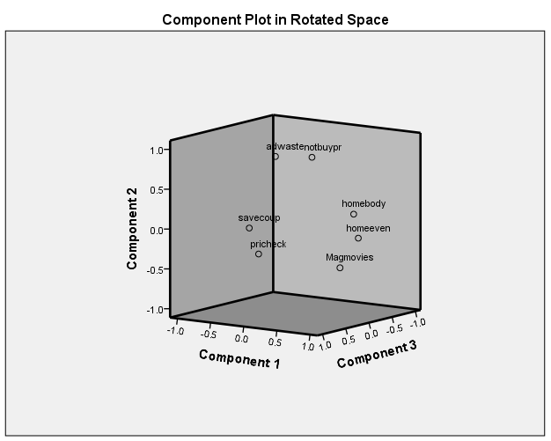

Component Score Coefficient Matrix
 | Component
 | 1 | 2 | 3
Spent Evening at Home | .391 | .020 | -.048
Always Check Prices | .010 | -.048 | .530
Magazines Better Than Movies | .302 | -.189 | .043
Would Not Buy Products on Billboards | .170 | .542 | .059
Am a Homebody | .405 | .211 | .021
Save and Cash Coupons | -.008 | .145 | .595
Ads are Waste | -.086 | .461 | .035

Extraction Method: Principal Component Analysis.
Rotation Method: Varimax with Kaiser Normalization.
Component Scores.

Component Score Covariance Matrix
Component | 1 | 2 | 3
1 | 1.000 | .000 | .000
2 | .000 | 1.000 | .000
3 | .000 | .000 | 1.000

Extraction Method: Principal Component Analysis.
Rotation Method: Varimax with Kaiser Normalization.
Component Scores.

CORRELATIONS
/VARIABLES=StayatHome_fs Skeptisem_fs PriceSensitive_fs
/PRINT=TWOTAIL NOSIG
/MISSING=PAIRWISE.

Correlations

Notes
Output Created |  | 26-MAR-2017 15:49:39
Comments
Input | Data | C:\Home\Work\GreatLakes\Advanced Stats\practice data\household and shopping behaviour.sav
Input | Active Dataset | DataSet4
Input | Filter | <none>
Input | Weight | <none>
Input | Split File | <none>
Input | N of Rows in Working Data File | 25
Missing Value Handling | Definition of Missing | User-defined missing values are treated as missing.
Missing Value Handling | Cases Used | Statistics for each pair of variables are based on all the cases with valid data for that pair.
Syntax |  | CORRELATIONS  /VARIABLES=StayatHome_fs Skeptisem_fs PriceSensitive_fs  /PRINT=TWOTAIL NOSIG  /MISSING=PAIRWISE.
Resources | Processor Time | 00:00:00.03
Resources | Elapsed Time | 00:00:00.02

[DataSet4] C:\Home\Work\GreatLakes\Advanced Stats\practice data\household and shopping behaviour.sav

Correlations
 |  | Stay at Home | Skeptic | Prise Senstive
Stay at Home | Pearson Correlation | 1 | .000 | .000
Stay at Home | Sig. (2-tailed) |  | 1.000 | 1.000
Stay at Home | N | 25 | 25 | 25
Skeptic | Pearson Correlation | .000 | 1 | .000
Skeptic | Sig. (2-tailed) | 1.000 |  | 1.000
Skeptic | N | 25 | 25 | 25
Prise Senstive | Pearson Correlation | .000 | .000 | 1
Prise Senstive | Sig. (2-tailed) | 1.000 | 1.000
Prise Senstive | N | 25 | 25 | 25

Orthoganal and bicolinearity

REGRESSION
/MISSING LISTWISE
/STATISTICS COEFF OUTS R ANOVA
/CRITERIA=PIN(.05) POUT(.10)
/NOORIGIN
/DEPENDENT tentruor
/METHOD=ENTER StayatHome_fs Skeptisem_fs PriceSensitive_fs
/RESIDUALS HISTOGRAM(ZRESID).

Regression

Notes
Output Created |  | 26-MAR-2017 15:50:47
Comments
Input | Data | C:\Home\Work\GreatLakes\Advanced Stats\practice data\household and shopping behaviour.sav
Input | Active Dataset | DataSet4
Input | Filter | <none>
Input | Weight | <none>
Input | Split File | <none>
Input | N of Rows in Working Data File | 25
Missing Value Handling | Definition of Missing | User-defined missing values are treated as missing.
Missing Value Handling | Cases Used | Statistics are based on cases with no missing values for any variable used.
Syntax |  | REGRESSION  /MISSING LISTWISE  /STATISTICS COEFF OUTS R ANOVA  /CRITERIA=PIN(.05) POUT(.10)  /NOORIGIN  /DEPENDENT tentruor  /METHOD=ENTER StayatHome_fs Skeptisem_fs PriceSensitive_fs  /RESIDUALS HISTOGRAM(ZRESID).
Resources | Processor Time | 00:00:00.28
Resources | Elapsed Time | 00:00:00.27
Resources | Memory Required | 3920 bytes
Resources | Additional Memory Required for Residual Plots | 280 bytes

[DataSet4] C:\Home\Work\GreatLakes\Advanced Stats\practice data\household and shopping behaviour.sav

Variables Entered/Removedª
Model | Variables Entered | Variables Removed | Method
1 | Prise Senstive, Skeptic, Stay at Home^{b} | . | Enter

a. Dependent Variable: Tendency to trust online reviews
b. All requested variables entered.

Model Summary^{b}
Model | R | R Square | Adjusted R Square | Std. Error of the Estimate
1 | .748ª | .559 | .496 | 1.10782

a. Predictors: (Constant), Prise Senstive, Skeptic, Stay at Home
b. Dependent Variable: Tendency to trust online reviews

ANOVAª
Model |  | Sum of Squares | df | Mean Square | F | Sig.
1 | Regression | 32.662 | 3 | 10.887 | 8.871 | .001^{b}
1 | Residual | 25.773 | 21 | 1.227
1 | Total | 58.435 | 24

a. Dependent Variable: Tendency to trust online reviews
b. Predictors: (Constant), Prise Senstive, Skeptic, Stay at Home

Coefficientsª
Model |  | Unstandardized Coefficients |  | Standardized Coefficients | t | Sig.
 |  | B | Std. Error | Beta | t | Sig.
1 | (Constant) | 2.240 | .222 |  | 10.110 | .000
1 | Stay at Home | .998 | .226 | .640 | 4.415 | .000
1 | Skeptic | .519 | .226 | .333 | 2.295 | .032
1 | Prise Senstive | .308 | .226 | .197 | 1.361 | .188

a. Dependent Variable: Tendency to trust online reviews

Staying at Home is signifiant

Residuals Statisticsª
 | Minimum | Maximum | Mean | Std. Deviation | N
Predicted Value | .1579 | 4.0994 | 2.2400 | 1.16659 | 25
Residual | -2.11566 | 1.78052 | .00000 | 1.03627 | 25
Std. Predicted Value | -1.785 | 1.594 | .000 | 1.000 | 25
Std. Residual | -1.910 | 1.607 | .000 | .935 | 25

a. Dependent Variable: Tendency to trust online reviews

Charts

